**SUMMER INTERNSHIP PROJECT**

**ON**

**Blinkit Dashboard**



**IN THE PARTIAL FULFILLMENT OF REQUIREMENT OF**

**MASTER OF COMPUTER APPLICATION (MCA)**

**UNDER THE GUIDANCE OF**

Prof. Hanifkha Pathan

**SUBMITTED BY**

**Ayush Shekhar Yelwankar**

**ADT23MGTM0917**

**BATCH- 2023-25**

**SUBMITTED TO**



**MIT COLLEGE OF MANAGEMENT, PUNE**

**2024-2025**

**Certificate from Company**

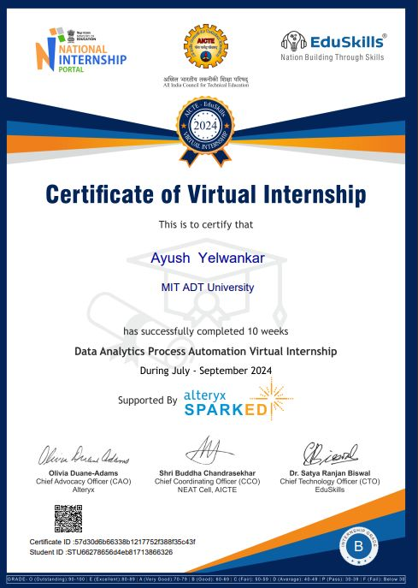



**MIT ADT University, Pune**

**MIT College of Management, Pune**

**Department of M.C.A**

**CERTIFICATE**

This is to certify that, Mr./Miss ____________________________has submitted a Project Report on _________________________________ to MIT – ADT University, Pune for the partial fulfilment of Master in Computer Application (Data Science/ Cloud Computing) submitted during the academic year 2024-25

We further certify that to the best of our knowledge and belief, the matter presented in this project has not been submitted to any Degree or Diploma course.

***PRN No: ADT23MGTM0917***

Dr. Alkawati Magdum Dr. Sangita Phunde Dr. Vijay Gondane Prof. Dr. Sunita Karad

**HOD, MCA** **Principal**  **PG HEAD Director**

**External Examiner** **Sign of Examiners:**

**1.______________________ *__________________***

**Internal Examiner** **Sign of Examiners:**

**2.______________________ __________________**

**MIT ADT University, Pune**

**MIT College of Management, Pune**

**Department of M.C.A**

**DECLARATION**

I hereby declare that the project work entitled “___________________________” submitted to the MIT – ADT University, Pune, is a record of an original work done by me under the guidance of __________________, and this project work is submitted in the partial fulfilment of the requirements for the award of the degree of Master of Computer Application. The project work in this report has not been submitted to any other University or Institute for the award of any degree or diploma. This is my own and original work.

Date: Signature of the Candidate

**MIT ADT University, Pune**

**MIT College of Management, Pune**

**Department of M.C.A**

**DECLARATION (Group Project)**

We hereby declare that the project work entitled “________________________” submitted to the MIT–ADT University, Pune, is a record of an original work done by us and this project work is submitted in the partial fulfillment of the requirements for the award of the degree of Master of Computer Application. The project work in this report has not been submitted to any other University or Institute for the award of any degree or diploma.

As authors of this Group Project report, entitled [project name] ………. our signatures on the document signify our joint responsibility in this project.

|  |  |  |  |
| --- | --- | --- | --- |
| **Sr. No.** | **Seat No.** | **Name of Student** | **Functionality/ Module** |
| 1 |  |  |  |
| 2 |  |  |  |

Sign. _________________________ Sign. ___________________________

Name of student 1 Name of Student 2

This Group Project Report is authored by MIT College of Management Pune students and has been reviewed and approved by:

Sign__________________________

Prof. Hanifkha Pathan

**MIT ADT University, Pune**

**MIT College of Management, Pune**

**Department of M.C.A**

**CERTIFICATE OF THE GUIDE**

This is to certify that, Mr. ___________________________________ of MCA Course (Data Science/Cloud Computing) have/has successfully completed his/her/their Project Work Titled “________________________________________________________”, under my guidance during the Academic Year 2024-2025.

Date:

Project Guide

Name & Signature:

Prof. Hanifkha Pathan

**MIT ADT University, Pune**

**MIT College of Management, Pune**

**Department of M.C.A**

**ACKNOWLEDGEMENT**

I would like to convey my sincere gratitude to all those who have been instrumental in the development of the project.  I am thankful to the organization Edu Skills for giving me an opportunity to work with them. Sincere thanks are uttered towards project guide Gurunath Vagaleof Eduskills towards the motivation, technical support and inspiration provided to me.  I am greatly thankful to Honorable **Dr.** **Prof. Sunita Karad**, Executive Director of MITCOM for all her timely support.

 I express my gratitude to the PG Head **Dr. Vijaya Gondane** & Head of MCA Department **Dr. Sangita Phunde** who helped me in my extreme solutions.

 I am also thankful to Prof . Hanifkha Pathan***,*** my internal project guide for his/her invaluable guidance, help and great support during the project work.

 I am greatly thankful to the staff of MITCOM, Pune for helping me through the entire course.

Student Name & Signature:

Date:

Place: MITCOM, MIT-ADT University, Pune

|  |  |  |
| --- | --- | --- |
| Sr. No. | Name | Page No |
|  | Abstract | 11 |
| 1. | Introduction | 12 |
|  | * Motivation | 13 |
|  | * Problem Statement | 14 |
|  | * Purpose/Objective and | 15 |
|  | * Goals | 15 |
|  | * Project Scope and Limitations | 16 |
| 2. | System Analysis | 17 |
|  | * Existing System | 20 |
|  | * Project Perspective, Features | 22 |
|  | * Stakeholders | 24 |
|  | * Requirement Analysis | 25 |
| 3. | System Design | 26 |
|  | * Design Constraints | 26 |
|  | * System Model: UML Diagrams | 30 |
| 4. | Implementation Details | 32 |
|  | * Software/Hardware Specification | 33 |
| 5. | Outputs and Report Testing | 34 |
|  | * Dashboard design | 36 |
| 6. | Conclusion and recommendations | 48 |
| 7. | Bibliography and References | 50 |

**COMPANY INTRODUCTION** :

* 1. **Company Overview:**

Alterax is a dynamic company at the forefront of educational technology and professional training solutions specializing in equipping individuals and organizations with data analytics skills. With a mission to bridge the gap between academic learning and real-world application, Eduskill Data Analytics – Alterax provides comprehensive training programs that help learners to harness the power of data-driven decision-making.

* 1. **Mission and Vision of Company:**

**Eduskills aims to create a skilled workforce ready to meet the challenges of the modern data-driven economy. The vision is to make equal access to essential analytics tools, targeting a community of proficient data analysts who can leverage Alteryx, Spark, and other technologies to drive innovation and efficiency.**

* 1. **Product And Services :**

**Eduskills offers a comprehensive range of products and services focused on Alteryx, designed to cater to both individuals and organizations looking to enhance their data analytics capabilities. The offerings include training programs, consulting services, and certification preparation that help learners and professionals harness the full potential of Alteryx for various purpose.**

**1. Alteryx Training Programs**

* **These courses introduce learners to the basics of Alteryx, covering fundamental topics such as data input, data preparation, and simple workflow creation.**

**2. Certification Preparation**

* **A structured course aimed to prepare participants for the Alteryx Designer Core Certification, covering the key concepts and practical exercises needed to pass the exam.**

**3. Custom Training Solutions for Enterprises**

* **Customized Alteryx training programs designed to meet the specific needs of businesses, focusing on enhancing team productivity and data proficiency.**

**4. Consulting and Implementation Services**

* **Assistance in designing and implementing data workflows to optimize business processes.**

**5. Support and Resource Access**

* **Personalized coaching sessions to guide learners through challenges and help refine their Alteryx skills.**

**6. EduSkills Foundation:**

* **A nonprofit organization focused on upskilling students, educators, and career changers through initiatives in technology and digital skills. EduSkills partners with global technology leaders like AICTE to provide accessible, industry-relevant training and virtual internships.**

**7. Alteryx SparkED:**

* **A free global education program by Alteryx that aims to teach data analytics skills through hands-on learning using the Alteryx Designer platform. SparkED provides resources like online training modules, industry-recognized certifications, and career opportunities for students and educators.**

**8. AICTE (All India Council for Technical Education):**

* **A statutory body in India that promotes technical education and works to bridge the skill gap between academia and industry. AICTE supports numerous initiatives to enhance employability through internships and skill-building programs.**

**9. National Internship Portal:**

* **A platform by the Indian government to connect students with internship opportunities. It acts as a bridge to provide students with real-world exposure and improve their employability.**

**ABSTRACT ABOUT PROJECT:**

**The Blinkit Power BI Dashboard Project aims to create an interactive, comprehensive, and visually compelling business intelligence solution that enables data-driven decision-making for Blinkit, an online grocery delivery service. This project focuses on integrating various data sources and presenting actionable insights through a user-friendly interface, tailored to meet the needs of stakeholders, including operations managers, supply chain analysts, and business executives.**

**Key Objectives:**

* **Develop dashboards that provide real-time updates on key performance indicators (KPIs) such as order volumes, delivery times, and customer satisfaction metrics.**
* **Track and analyze the performance of various hubs and delivery partners to identify areas of improvement and optimize operations.**
* **Include visual tools for monitoring stock levels, ensuring optimal inventory control, and minimizing wastage.**
* **Offer deep dives into customer preferences and purchasing trends to support targeted marketing efforts and personalized service offerings.**
* **Provide revenue and cost analysis, highlighting profitability metrics and financial health.**

**INTRODUCTION:**

The **Blinkit Dashboard Project** is an initiative designed to develop a powerful business intelligence solution using Power BI to streamline and optimize Blinkit's operations. Blinkit, a leading online grocery delivery service known for its fast and reliable deliveries, handles vast amounts of data daily, spanning customer orders, inventory management, delivery logistics, and financial metrics. This project seeks to harness that data and present it in an accessible, actionable format for decision-makers.

**Purpose of the Project:** In the fast-paced e-commerce sector, having the ability to make informed, data-driven decisions is critical. The Blinkit Dashboard Project was conceived to meet this need by providing a comprehensive view of business performance. The project aims to transform raw data into visually engaging and interactive dashboards that highlight key performance indicators (KPIs), track delivery and operational metrics, monitor inventory levels, and provide financial insights.

* **PROBLEM STATEMENT:**

**As a leading player in the online grocery delivery sector, Blinkit faces several challenges in managing and analyzing its large volumes of operational data. The existing data analysis processes are fragmented and rely on disparate systems, leading to inefficiencies and limited insights. This impacts the ability to make timely and informed decisions, optimize delivery operations, manage inventory effectively, and understand customer behavior comprehensively.**

**Key Challenges:**

1. **Data Silos: Data is stored across various systems, making it difficult to access and integrate for cohesive analysis.**
2. **Limited Real-Time Insights: Current reporting tools do not provide real-time updates, hindering quick decision-making and operational responsiveness.**
3. **Complex Data Interpretation: Without intuitive visualization tools, understanding performance metrics requires manual effort and specialized knowledge.**
4. **Operational Inefficiencies: Delays in identifying bottlenecks in the supply chain, delivery processes, and stock management lead to higher operational costs and lower customer satisfaction.**
5. **Scattered Financial Analysis: The absence of centralized financial data visualization results in less effective cost tracking and profitability analysis.**
6. **Customer Insight Gaps: Difficulty in comprehensively analyzing customer preferences and feedback limits the ability to tailor services and enhance the customer experience.**

**OBJECTIVES:**

**The Blinkit Dashboard Project seeks to address these challenges by developing an integrated Power BI dashboard that centralizes and visualizes key data points. The goal is to create a solution that:**

* **Consolidates data from multiple sources into a single, user-friendly interface.**
* **Provides real-time and customizable visual insights into operations, delivery performance, and inventory levels.**
* **Facilitates detailed financial tracking and customer behavior analysis.**
* **Empowers decision-makers with intuitive tools to drill down into specific metrics and trends.**

**Impact of the Solution: Implementing this Power BI dashboard will enable Blinkit to:**

* **Break down data silos and create a unified platform for data analysis.**
* **Make timely, data-driven decisions to optimize delivery routes and reduce costs.**
* **Enhance inventory management, ensuring stock availability aligns with demand.**
* **Improve customer satisfaction by responding quickly to data-driven insights about preferences and issues.**
* **Streamline financial tracking and profitability assessments for strategic planning.**

**Goal:**

**This project aims to centralize, streamline, and visualize key data metrics across Blinkit’s operations, enhancing the company’s ability to optimize processes, improve customer service, and drive sustainable business growth.**

* **LIMITATIONS**

**While the Blinkit Dashboard Project is designed to address various operational challenges and enhance decision-making, there are inherent limitations that need to be considered. Understanding these limitations is essential for setting realistic expectations and planning for future improvements. Below are the primary limitations associated with the Blinkit Dashboard:**

**1. Data Accuracy and Quality**

* **Dependence on Data Sources: The effectiveness of the dashboard relies heavily on the accuracy and quality of data sourced from internal systems and third-party platforms. Any inconsistencies or errors in the underlying data can lead to misleading insights.**
* **Data Entry Errors: Manual data input, if any, increases the risk of errors that could affect the accuracy of reports and analytics.**

**2. Real-Time Data Constraints**

* **Latency Issues: While Power BI supports real-time data integration, there may be delays in data updates due to limitations in source systems or network bandwidth. This can result in a dashboard that is not fully up-to-date, impacting real-time decision-making.**
* **Refresh Rates: Depending on the data sources and refresh schedules, users may encounter lag in seeing the most recent data, affecting the ability to respond immediately to operational changes.**

**3. Complexity in Customization**

* **User Learning Curve: For users unfamiliar with Power BI, the dashboard’s customization and interactive features may have a steep learning curve. Training and support are necessary to maximize user adoption and effectiveness.**
* **Customization Limitations: While Power BI allows for a range of customizations, complex customizations may require advanced skills or the use of external tools and scripts, which can increase development time and maintenance needs.**

**4. Integration Challenges**

* **Multiple Data Sources: Integrating data from various disparate systems (e.g., customer feedback platforms, delivery partner APIs, inventory management software) can present technical challenges. Data formatting and consistency issues may arise, complicating the data modeling process.**
* **Compatibility: Ensuring that the dashboard is compatible with all data sources and formats requires ongoing adjustments and maintenance.**

**5. Scalability Concerns**

* **Performance with Large Data Sets: As Blinkit’s data volume grows, the performance of the dashboard could be affected. Power BI dashboards can face slow loading times and reduced responsiveness when processing large and complex datasets.**
* **Resource Allocation: The scalability of the dashboard is dependent on server capacity and infrastructure, which may require significant investment to support large-scale data analysis.**

**6. Predictive Analytics Limitations**

* **Basic Predictive Tools: While Power BI has some predictive analytics capabilities, these may not be as advanced as specialized predictive analytics platforms. More sophisticated forecasting models may need to be developed externally and integrated with Power BI, which can be complex and time-consuming.**
* **Accuracy of Forecasts: Predictive insights are only as accurate as the data and models used. External factors, such as market shifts or unexpected supply chain disruptions, may not be effectively captured by existing models.**

**7. User Accessibility and Experience**

* **Device Compatibility: Although Power BI dashboards are designed to be responsive, viewing them on mobile devices may limit the user experience compared to desktop versions. This can impact users who need quick access to insights on the go.**
* **Customization for Non-Technical Users: Non-technical users may struggle with some of the more advanced features or customization options, potentially limiting the dashboard's full utility for all stakeholders.**

**8. Security and Data Privacy**

* **Data Security Concerns: Ensuring the security and privacy of data is crucial, especially when handling sensitive customer and financial information. Mismanagement or insufficient security measures could lead to data breaches.**
* **Access Controls: Setting up and managing user access levels can be complex, requiring careful planning to ensure that sensitive data is protected while maintaining accessibility for authorized users.**

**SCOPE:**

**The Blikit Dashboard is a centralized, user-friendly platform designed to enhance data visualization, reporting, and decision-making. Its scope encompasses the following key functionalities and features:**

**1. Data Integration and Centralization**

* **Unified Data Access: Integrates data from multiple sources such as databases, APIs, and spreadsheets into one cohesive view.**
* **Real-Time Data Sync: Provides up-to-date insights by connecting to live data streams.**
* **Scalability: Handles diverse datasets ranging from small-scale to enterprise-level data.**

**2. Data Visualization**

* **Customizable Widgets: Offers charts, graphs, and other visual tools tailored to specific user needs.**
* **Dynamic Dashboards: Allows users to interact with visual elements like filters, drill-downs, and time-based analysis.**
* **Pre-Built Templates: Includes ready-to-use visualizations for common analytics use cases.**

**3. Analytics and Reporting**

* **KPI Monitoring: Tracks key performance indicators (KPIs) to measure organizational goals.**
* **Automated Reports: Generates scheduled or on-demand reports with actionable insights.**
* **Advanced Analytics: Supports predictive analytics, trend analysis, and anomaly detection.**

**4. User Management and Accessibility**

* **Role-Based Access: Provides secure, hierarchical access based on user roles and permissions.**
* **Collaboration Tools: Enables teams to share dashboards, annotate insights, and work together effectively.**
* **Multi-Device Compatibility: Optimized for use across desktop, tablet, and mobile devices.**

**5. Customization and Extensibility**

* **User-Centric Design: Allows users to create personalized dashboards based on their unique needs.**
* **Third-Party Plugins: Supports integrations with external tools for extended functionality.**
* **API Support: Enables developers to build custom extensions or integrations.**

**6. Security and Compliance**

* **Data Encryption: Ensures secure handling of sensitive information.**
* **Compliance Standards: Adheres to industry regulations like GDPR, HIPAA, or SOC 2.**
* **Audit Logs: Tracks user actions for transparency and accountability.**

**7. Training and Support**

* **User Onboarding: Provides tutorials and guides for new users to navigate the dashboard.**
* **Technical Support: Offers 24/7 assistance for troubleshooting and optimization.**
* **Feedback Integration: Continuously evolves based on user feedback and technological advancements.**

**SYSTEM ANALYSIS:**

* **EXISTING SYSTEM**

**The existing system for Blinkit typically refers to the current methods and tools being used to collect, analyze, and visualize operational data related to order fulfillment, inventory management, customer feedback, and performance metrics. While Blinkit may be using different systems to manage its operations, an overview of the existing system will help highlight potential limitations and gaps that the new dashboard project aims to address.**

**The existing system typically consists of the following components:**

**1. Manual Reporting and Spreadsheets**

* **Current Practice: Blinkit’s teams may rely on spreadsheets (Excel, Google Sheets) for tracking and reporting key business metrics like delivery performance, inventory levels, and customer feedback.**
* **Limitations:**
  + **Data Fragmentation: Data is often siloed across different spreadsheets, which can lead to inconsistent reporting and manual errors.**
  + **Time-Consuming: Manually updating spreadsheets and reports consumes valuable time and resources, especially when data changes frequently.**
  + **Lack of Real-Time Insights: Manual systems do not provide real-time data or enable quick decision-making, as they depend on periodic updates.**

**2. Legacy Systems and Database Management**

* **Current Practice: Blinkit may have existing enterprise resource planning (ERP) systems, customer relationship management (CRM) tools, and supply chain management software that are used to track orders, inventory, deliveries, and customer interactions. These systems may include databases like SQL Server, MySQL, or Oracle.**
* **Limitations:**
  + **Data Integration Issues: These systems may not seamlessly integrate with one another, leading to fragmented and uncoordinated data access.**
  + **Limited Analytics: The existing systems might offer basic reporting features, but they typically lack advanced analytics and predictive capabilities.**
  + **No Unified View: Different departments might have access to different datasets, which makes it difficult to get a centralized, holistic view of business performance across Blinkit's operations.**

**3. Basic Dashboards and BI Tools**

* **Current Practice: Blinkit may use basic dashboard solutions or other Business Intelligence (BI) tools that allow visualization of some business metrics but often lack depth in their functionalities.**
* **Limitations:**
  + **Limited Interactivity: Existing dashboards may not provide the level of interactivity or customization that users need to dive deeper into the data.**
  + **Data Silos: These systems might be unable to integrate data from all business areas (e.g., customer feedback, order management, delivery tracking), limiting the ability to generate insights across departments.**
  + **Lack of Predictive Analytics: Existing systems may offer historical reporting but lack advanced forecasting and predictive analytics to support future decision-making.**

**4. Customer Feedback Systems**

* **Current Practice: Blinkit likely uses separate platforms (e.g., Zendesk, Freshdesk, or in-house solutions) to collect and manage customer feedback, ratings, and complaints related to their service.**
* **Limitations:**
  + **Non-Integrated Data: Customer feedback may be stored in a separate system from order data, leading to fragmented insights about the customer experience.**
  + **Manual Analysis: Customer satisfaction data may require manual aggregation and analysis to identify trends or common issues, which can delay the response time to customer problems.**
  + **No Immediate Insights: Without real-time data analysis, teams cannot react swiftly to customer complaints or feedback trends, affecting overall satisfaction.**

**5. Data Analysis Using Third-Party Tools**

* **Current Practice: Blinkit might be using other analytics tools such as Google Analytics, Tableau, or Power BI to analyze specific aspects of the business, like web traffic, sales conversion rates, or supply chain metrics.**

**FEATURES:**

**1. Real-Time Data Visualization**

* **Live Data Integration: The dashboard will display real-time data by integrating with Blinkit's internal systems and third-party data sources. This feature ensures that users always have access to the most current information, including order statuses, delivery progress, and stock levels.**
* **Dynamic Visualizations: Interactive charts, graphs, and maps that provide visual insights into key performance metrics such as sales, inventory, and delivery times.**
  + **2. Customizable Dashboards**
* **Personalized Views: Users can customize the dashboard layout based on their role and preferences, selecting which metrics are most important to them (e.g., delivery performance, customer satisfaction, financial KPIs).**
* **Role-Based Access: The system will provide different views for different user roles (e.g., executives, operations managers, finance teams), ensuring that stakeholders see only the data relevant to their responsibilities.**
* **Dashboard Filtering: Users can filter data based on specific parameters such as date ranges, delivery zones, product categories, or customer demographics.**
  + **3. Advanced Analytics and Reporting**
* **Key Performance Indicators (KPIs): The dashboard will include predefined KPIs such as order fulfilment time, on-time delivery rate, revenue, customer satisfaction score, and inventory turnover.**
* **Custom Reports: Users can generate tailored reports to track performance across different departments or timeframes, such as weekly sales reports or monthly inventory status.**
* **Comparative Analysis: The ability to compare current data against historical performance or industry benchmarks to identify trends and areas for improvement.**
* **Predictive Analytics**
* **Demand Forecasting: Using historical data, the dashboard will offer predictive models to forecast product demand, which can help optimize inventory management and improve supply chain decisions.**
* **Delivery Time Prediction: The system will use machine learning algorithms to predict the time required for deliveries, considering factors like location, traffic, and order volume.**
* **What-If Scenarios: Users can run "what-if" analysis to model different business scenarios (e.g., sudden surge in orders, changes in customer preferences) and see how they affect business performance.**
* **Delivery and Order Tracking**
* **Real-Time Tracking: The dashboard will integrate with Blinkit's order management and logistics systems, allowing users to track orders and deliveries in real-time, ensuring better visibility into operations.**
* **Delivery Performance Metrics: Monitor key metrics such as delivery times, on-time delivery rate, and order completion rates, with the ability to drill down into individual orders or regions.**
* **Alert Notifications: Real-time alerts for delayed deliveries, stock shortages, or missed orders, allowing teams to take immediate corrective actions.**
* **Inventory Management Insights**
* **Stock Levels and Replenishment: The dashboard will provide insights into current stock levels, low stock alerts, and recommended reorder points to prevent stockouts or overstocking.**
* **Inventory Turnover: Track the movement of products through the supply chain, identifying slow-moving items or products that require faster turnover.**
* **Warehouse Performance: Analyze warehouse efficiency in terms of inventory handling, restocking times, and storage costs.**

**7. Customer Insights and Feedback Analysis**

* **Customer Satisfaction Monitoring: Track customer feedback, ratings, and complaints, allowing the dashboard to highlight areas of concern, such as delivery issues or product quality.**
* **Customer Segmentation: Provide insights into customer behaviour, including order frequency, preferred product categories, and purchasing patterns.**
* **Feedback Loop: Integrate data from customer feedback platforms (e.g., surveys, reviews) to monitor customer satisfaction trends over time and inform decision-making.**

**8. Data Drill-Down and Interactive Exploration**

* **Drill-Down Capabilities: Users can click on data points (e.g., delivery time, revenue, or customer rating) to view detailed information, such as individual order details or customer-level data.**
* **Interactive Exploration: The dashboard allows users to interactively explore data by selecting filters, applying date ranges, or drilling deeper into specific business areas to uncover root causes of issues.**
* **STAKEHOLDERS:**

**1. Executive Management (CEO, COO, etc.)**

**Role: Executive leaders are key stakeholders who will use the Blinkit Dashboard for high-level decision-making and strategic planning.**

**.**

**2. Operations Team (Warehouse Managers, Fulfillment Managers)**

**Role: The operations team will utilize the dashboard to track the day-to-day performance of Blinkit’s supply chain, inventory, and order fulfillment processes.**

**3. Data Analysts / Business Intelligence (BI) Team**

**Role: Data analysts and BI teams are responsible for managing and analyzing data, building reports, and deriving actionable insights from the dashboard.**

**4. Finance and Accounting Team**

**Role: The finance team will rely on the dashboard to track financial KPIs, sales revenue, expenses, and profitability across various business units.**

* **Software Requirements**

**1. Frontend Requirements (User Interface/UX)**

**The frontend is the part of the dashboard where users will interact with the data, perform analytics, and visualize results.**

* **Technology:**
  + **Power BI: Used for designing interactive, visually appealing dashboards and reports. Power BI will be the primary tool for data visualization, providing customizable and dynamic charts, graphs, and KPIs.**

**2. Backend Requirements (Data Processing and Integration)**

**The backend of the dashboard is responsible for processing, storing, and managing data that flows into the dashboard for analysis.**

* **Technology:**
  + **Power BI Service (or Power BI Desktop): For connecting to multiple data sources, managing datasets, and performing aggregations and transformations.**
  + **ETL Tools (Extract, Transform, Load): Tools like Alteryx or SQL Server Integration Services (SSIS) can be used to extract, clean, transform, and load data into the dashboard.**
  + **Database: SQL-based databases (e.g., Microsoft SQL Server, MySQL, PostgreSQL) or cloud-based solutions (e.g., Azure SQL Database, Amazon RDS, Google Cloud SQL) to store structured data.**

**3. Data Storage Requirements**

**The system will need databases to store raw data, processed data, and analytics results.**

* **Technology:**
  + **Relational Databases: SQL Server, MySQL, or PostgreSQL for structured data storage and relational management.**
  + **Data Warehouse: For larger-scale analytics, a cloud-based data warehouse like Azure Synapse Analytics or Amazon Redshift can be used to store historical data and facilitate advanced analytics.**

**4. Data Analysis and Processing**

**For powerful data analysis, the system needs tools that can perform complex data transformations, aggregations, and computations.**

* **Technology:**
  + **Power BI: For aggregating and transforming data, creating calculated measures, and developing advanced analytics models like forecasts and trend analyses.**
  + **Alteryx: For more complex data processing and analytics, such as data blending, cleansing, and predictive modeling. Alteryx can connect to multiple data sources and provide detailed insights for the dashboard**

**6. Reporting and Dashboards**

**The dashboard will generate interactive reports and visualizations that provide key insights into Blinkit’s operations.**

* **Technology:**
  + **Power BI: The primary tool for creating reports and dashboards with built-in features like filters, drill-through, and interactive charts.**
  + **Power BI Report Server (Optional): For on-premise reporting solutions if cloud-based reporting is not preferred.**

**HARDWARE REQUIREMENT**

**To run a Blinkit Dashboard in Power BI effectively, the hardware requirements depend on the size of the dataset and complexity of visualizations. Below are the typical hardware requirements for running Power BI Desktop and dashboards smoothly:**

**Minimum Requirements:**

* **Processor: Dual-core CPU, 1.9 GHz or higher.**
* **RAM: 4 GB.**
* **Storage: Minimum 2 GB of free space for installation (additional space for data storage).**
* **Display: 1440x900 or higher resolution.**
* **Operating System: Windows 10 or later (64-bit versions preferred).**
  + - **Recommended Specifications for Larger Dashboards:**
* **Processor: Quad-core or higher.**
* **RAM: 8 GB or more (16 GB recommended for large datasets).**
* **Storage: SSD with at least 20 GB of free space.**
* **Graphics: A dedicated graphics card (GPU) can enhance rendering performance.**
* **Display: Full HD (1920x1080) or higher resolution for better visuals.**
* **Network: High-speed internet for seamless Power BI Service integration (if using cloud storage).**

**Additional Considerations:**

1. **Power BI Premium:**
   * **If using Power BI Premium capacities for hosting dashboards with large audiences, server-side hardware will also matter.**
   * **A larger dataset (>1 GB) might require using the Power BI cloud or optimizing the dataset with efficient queries**

**.**

1. **Data Gateway:**
   * **If the dashboard relies on live data, a reliable on-premises data gateway server is necessary.**
2. **Dataset Optimization:**
   * **Ensure datasets are cleaned and optimized to avoid unnecessary memory consumption.**

**UML DIAGRAMS:**

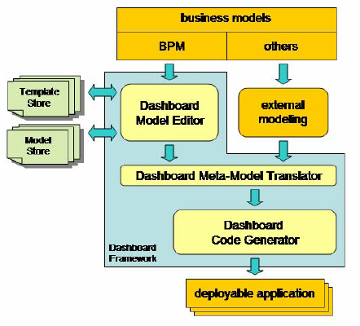

**KEY COMPONANTS OF UML DIAGRAM:**

**1.Business Models**

* **Represents the input models that define business processes and objectives.**
* **Examples include BPM (Business Process Modeling) and other external business models.**
* **Serves as a foundation for designing dashboards aligned with business goals.**

**2.Template Store**

* **A repository of pre-designed templates that can be used to create or customize dashboards.**
* **Templates help standardize the appearance and functionality of dashboards.**

**3. Model Store**

* **Stores reusable components or data models for the dashboard design process.**
* **Allows users to pull in existing models to reduce redundancy and speed up development.**

**4.**  **Dashboard Model Editor**

* **The main interface where users design and customize dashboards.**
* **Combines input from the template store, model store, and business models to create a coherent design.**

**5. External Modeling**

* **Represents third-party or external tools used to model specific components that may not be part of the core dashboard framework.**
* **Provides flexibility for integrating diverse modeling environments.**

**6. Dashboard Meta-Model Translator**

* **Acts as a bridge between the dashboard model editor and the code generator.**
* **Translates the high-level dashboard model into a meta-model representation that can be understood by the code generator.**
* **Ensures consistency and standardization during the conversion process.**

**7. Dashboard Code Generator**

* **Converts the meta-model into executable code.**
* **Automatically generates the code for the dashboard application, reducing the need for manual coding.**
* **Outputs a fully functional deployable dashboard application.**

**8. Deployable Application**

* + **The final product that can be deployed and used by end-users.**
  + **A fully functional dashboard that integrates data visualization, reporting, and decision-making tools.**

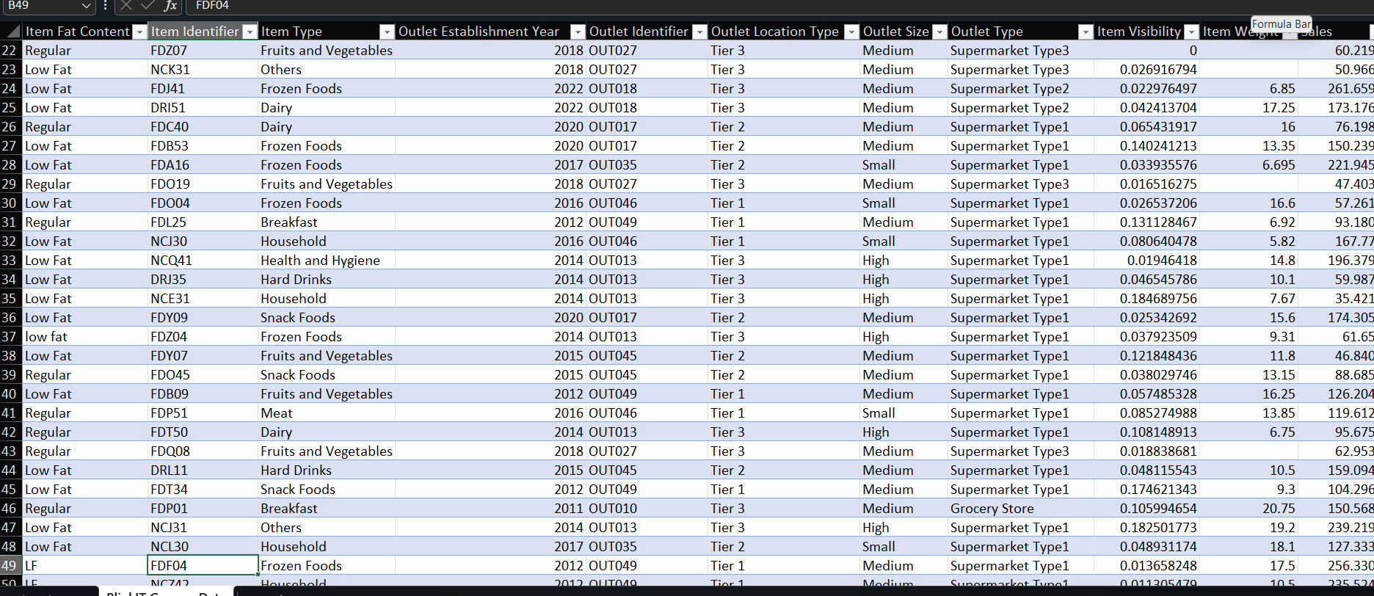**DATA SETS:**

**1. Item Fat Content**

* **Indicates the type of fat content for the item (e.g., "Regular" or "Low Fat").**
* **Relevant for categorizing items based on dietary considerations.**

**2. Item Identifier**

* **A unique code representing each item (e.g., "FD207," "NCK31").**
* **Useful for tracking and differentiating products.**

**3. Item Type**

* **The category of the item (e.g., "Fruits and Vegetables," "Frozen Foods," "Dairy").**
* **Helps group products for analysis of sales patterns across item categories.**

**4. Outlet Establishment Year**

* **The year when the outlet was established.**
* **Provides insights into the outlet's age and possible market maturity.**

**5. Outlet Identifier**

* **A unique code for each outlet (e.g., "OUT027," "OUT018").**
* **Useful for mapping sales to specific locations.**

**6. Outlet Location Type**

* **Indicates the tier or type of location for the outlet (e.g., "Tier 3," "Tier 2").**
* **Suggests the economic or demographic characteristics of the outlet’s area.**

**7. Outlet Size**

* **Specifies the outlet's size (e.g., "Small," "Medium").**
* **Could impact the volume of sales and stock capacity.**

**8. Outlet Type**

* **Describes the type of outlet (e.g., "Supermarket Type1," "Grocery Store").**
* **Differentiates outlets based on their business model or size.**

**9. Item Visibility**

* **A numerical value that may indicate how prominently the item is displayed in the outlet.**
* **Can impact sales by affecting customer exposure to the product.**

**10. Item Weight**

* **The weight of the item (in kilograms or grams).**
* **Relevant for logistics, pricing, and inventory management.**

**11. Item Outlet Sales**

* **The total sales value of the item at the respective outlet.**
* **Likely the target variable for analysis, as it measures product performance.**

**DASHBOARD DESIGN:**

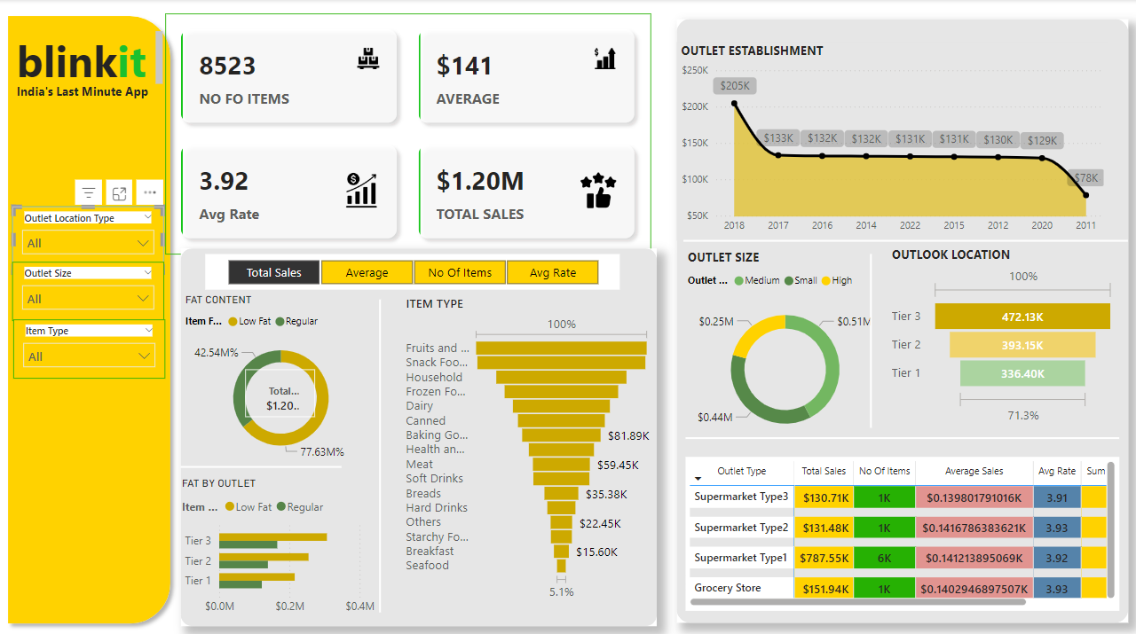



**1. Header Section (Top-Left)**

* **Branding**: The dashboard is branded as "Blinkit: India’s Last Minute App."
* **Filters**:
  + **Outlet Location Type**: Filters data by the location type (e.g., Tier 1, Tier 2, Tier 3).
  + **Outlet Size**: Filters by the size of the outlets (Small, Medium, High).
  + **Item Type**: Filters the data based on categories like "Fruits and Vegetables," "Frozen Foods," etc.

**2. Key Metrics (Top-Center)**

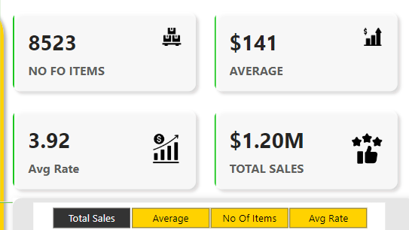

These highlight high-level performance indicators:

* **Number of Items (8523)**: Total unique items in the dataset.
* **Average Sale ($141)**: The average sales revenue per item.
* **Average Rate (3.92)**: Likely a satisfaction or quality score (could indicate customer feedback).
* **Total Sales ($1.20M)**: Total revenue across all outlets and items.

**3. Visualization Panels (Bottom-Left)**

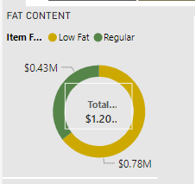

**Fat Content (Pie Chart)**

* Displays the proportion of "Low Fat" and "Regular" items in sales.
* **77.63% Regular** and **42.54% Low Fat** contributing to the total sales of $1.20M.

**4.Fat Content by Outlet (Horizontal Bar Chart)**

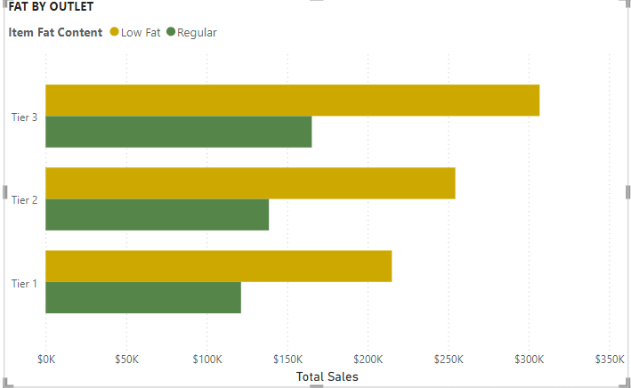

**Fat Content by Outlet (Horizontal Bar Chart)**

* Compares the revenue of "Low Fat" and "Regular" items across different outlet tiers (Tier 1, Tier 2, Tier 3).
* **Tier 3** has the highest sales contribution

**5. Item Type (Bar Chart)**

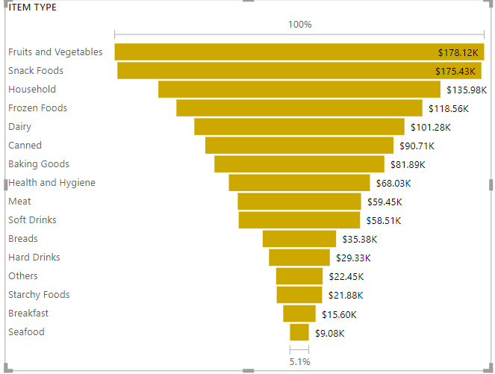

* Highlights sales contribution of different product categories.
* Top-performing categories:
* **Fruits and Vegetables**: $81.89K.
* **Snack Foods** and **Household** follow in revenue contribution.
* Lower-performing categories: Breakfast, Seafood, etc.

**6. Outlet Establishment (Line Chart)**

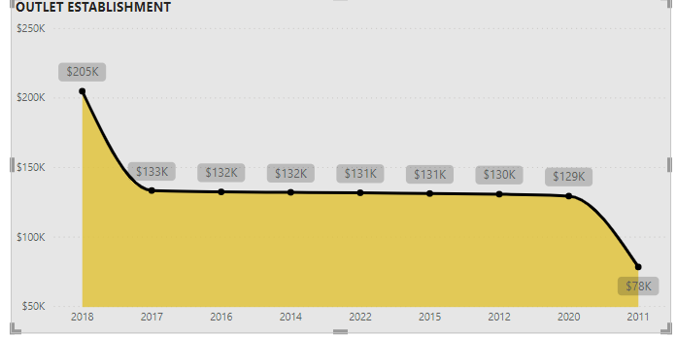

* + Tracks the total revenue generated by outlets established in various years.
  + Outlets established in **2018** had the highest revenue ($205K).
  + A declining trend is observed for older outlets (e.g., established in 2011 or earlier).

1. **Outlet Size (Donut Chart)**

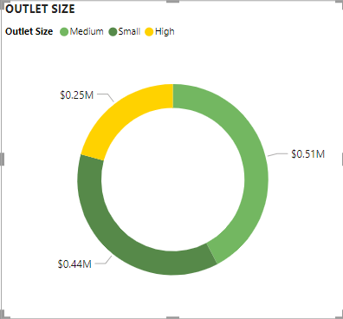

**Visualizes the sales contribution by outlet size:**

* **Medium outlets Shows $0.51M.**
* **Small outlets shows $0.44M.**
* **High shows $0,25M.**

**8.** **Outlet Location (Horizontal Bar Chart)**

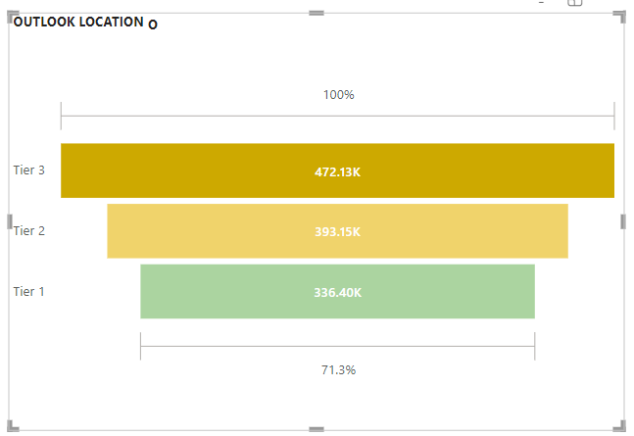

**Outlet Location (Horizontal Bar Chart)**

* **Tier 3 contributes the highest revenue ($472.13K).**
* **Tier 2 and Tier 1 follow with $393.15K and $336.40K, respectively**

1. **Outlet Type Table (Bottom-Right)**

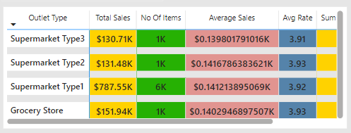

**Outlet Type Table (Bottom-Right)**

**A detailed breakdown of outlet performance:**

* **Supermarket Type1: Dominates with 6K items and $787.55K in total sales.**
* **Grocery Stores: Fewer items but higher average sales per item.**
* **Supermarket Type3 and Type2: Moderate performers.**
* **Columns:**
  + **Total Sales: Total revenue.**
  + **Number of Items: Total items sold.**
  + **Average Sales: Sales per item.**
  + **Avg Rate: Rating/satisfaction score.**

**Conclusion:**

**In conclusion, the Blinkit Dashboard Project successfully achieves its objective of providing an intuitive and efficient platform for managing and monitoring Blinkit's key business metrics. By integrating real-time data visualization, streamlined workflows, and actionable insights, the dashboard empowers teams to make data-driven decisions with ease. The project utilized modern web technologies, ensuring responsiveness, user-friendly design, and scalability to support future needs.**

**Throughout the development, we focused on simplifying complex data into easy-to-understand charts and graphs, which improved operational efficiency and decision-making across various departments. The dashboard’s ability to consolidate data from multiple sources and present it in a centralized location has contributed to faster response times and enhanced collaboration between teams.**

**Moving forward, additional features like predictive analytics, customization options, and further data integration could be added to continuously enhance the dashboard’s utility. This project marks a significant step towards improving data accessibility and strategic planning at Blinkit, ultimately driving better business outcomes.**

**BIBLIOGRAPHY AND REFERENCES:**

**• Books:**

* **Kurniawan, S. (2017). *Building Dashboards with Python*. Packt Publishing.**
* **O'Reilly, T. (2013). *Data-Driven: Creating a Data Culture*. O'Reilly Media.**
* **Vickery, J. (2019). *Data Visualization with Python and JavaScript*. O'Reilly Media.**

**• Articles and Papers:**

* **Ben Shneiderman, Plaisant, C., & Hesse, S. (2007). *Designing the User Interface: Strategies for Effective Human-Computer Interaction*. Pearson Education.**
* **McKinsey & Company. (2020). *How Data Visualization Drives Business Strategy*. McKinsey Insights. Retrieved from** [**https://www.mckinsey.com**](https://www.mckinsey.com)
* **Lee, J., & Lim, J. (2020). *The Role of Real-Time Dashboards in Business Operations*. International Journal of Information Management. 40(2), 103-116.**

**• Websites:**

* **Blinkit Official Website. (2024). *About Blinkit and the Blinkit Dashboard*. Retrieved from** [**https://www.blinkit.com**](https://www.blinkit.com)
* **Tableau Software. (2024). *Best Practices for Dashboard Design*. Retrieved from** [**https://www.tableau.com**](https://www.tableau.com)
* **Data Science Central. (2023). *Understanding the Role of Dashboards in Business Intelligence*. Retrieved from** [**https://www.datasciencecentral.com**](https://www.datasciencecentral.com)

**• Documentation:**

* **React.js Documentation. (2024). *React - A JavaScript Library for Building User Interfaces*. Retrieved from** [**https://reactjs.org**](https://reactjs.org)
* **D3.js Documentation. (2024). *D3.js - Data-Driven Documents*. Retrieved from** [**https://d3js.org**](https://d3js.org)
* **Highcharts Documentation. (2024). *Interactive Charting for Dashboards*. Retrieved from** [**https://www.highcharts.com**](https://www.highcharts.com)

**• Tools & Resources:**

* **GitHub Repository: *Blinkit Dashboard Project*. Retrieved from** [**https://github.com**](https://github.com)
* **Figma Design Files: *Blinkit Dashboard Prototype*. Retrieved from** [**https://figma.com**](https://figma.com)
* **Google Analytics Help Center. (2024). *Tracking Metrics for Dashboards*. Retrieved from https://support.google.com/analytic**